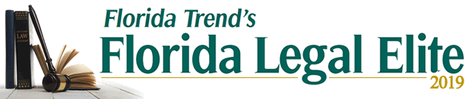

Florida Trend Magazine Recognizes 13 Dean Mead Attorneys as ‘Legal Elite’
Thirteen Dean Mead attorneys have been recognized among Florida Trend’s Florida Legal Elite 2019. The list appears in the July edition of the publication and includes five of the firm’s shareholders who are members of the distinguished Hall of Fame. Darryl M. Bloodworth, Lauren Y. Detzel, Peter M. Dunbar, Mark E. Holcomb, and Cari L. Roth have consistently earned high rankings from their peers in the annual Legal Elite voting.
Matthew J. Ahearn, in Dean Mead’s Orlando office, is newly admitted this year as a Legal Elite honoree. Ahearn is Board Certified in both Wills, Trusts & Estates and Tax Law by The Florida Bar Board of Legal Specialization. He has extensive experience in the areas of estate and business succession planning, asset protection planning, charitable planning and planning to minimize or avoid wealth transfer taxes.
The list of Dean Mead attorneys named among Florida Trend’s Florida Legal Elite are:
Matthew J. Ahearn
David J. Akins
Darryl M. Bloodworth – Hall of Fame
Lauren Y. Detzel – Hall of Fame
Marc W. Dunbar
Peter M. Dunbar – Hall of Fame
Martha J. Edenfield
Michael J. Furbush
William D. Hall, III – Up & Comer
David P. Hathaway
Mark E. Holcomb – Hall of Fame
Michael D. Minton
Cari L. Roth – Hall of Fame
Now in its 16th year, Florida Legal Elite presents a prestigious roster of attorneys chosen for recognition by their peers. The 1,126 lawyers listed in the 2019 edition exemplify a standard of excellence in their profession and by so doing, have garnered the respect and esteem of their colleagues. This list represents fewer than 1.3% of the active Florida Bar members who practice in Florida. The entire Legal Elite report can be viewed here.

