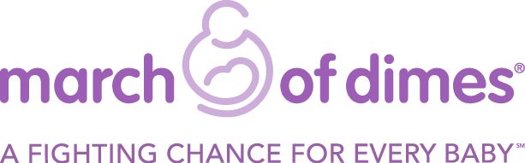

Monday, October 19, 2015
Media Contacts: Gregory C. Stephens, (321) 426-6230 GStephens@marchofdimes.org

7th ANNUAL MARCH OF DIMES SIGNATURE CHEFS AUCTION RAISES $100,575
TO GIVE A FIGHTING CHANCE FOR EVERY BABY

Melbourne, FL – March of Dimes Space Coast Division hosted its beloved annual food and wine event – Signature Chefs Auction on October 6th with more than 230 guests who raised $100,575 to help give a fighting chance for every baby.

The culinary benefit took place at the Hilton Rialto and was emceed by Mike & Mindy from Lite Rock 99.3, and featured some of the county’s top tier chefs and restaurants who prepared a wide selection of delectable bites. Sheriff Wayne Ivey was the Live Auctioneer and attendees also enjoyed fine wines and spirits while bidding on an impressive array of silent auction items.

The Ambassador Family, Patrick & Aran Hissam, shared their moving story of how March of Dimes-funded research is needed to end prematurity and birth defects so that every baby will have a fighting chance. They asked guests to make a tax-deductible gift to help “Fund the Mission” during the live auction portion of the event. If you would like to help fund the March of Dimes Campaign To End Prematurity, please visit http://prematurityresearch.org/.

A special thanks to all the participating chefs and restaurants, who truly made Signature Chefs Auction an incredible success: Lead Chef Josh Eslinger of Crush Eleven represented this year’s extravaganza along with Chef Lance S. Cook, C.E.C. of Eau Gallie Yacht Club, Chef Dave Dashi of Amici’s Italian Restaurant & Pizzeria, Chef Donald Edge of Hilton Rialto, Chef Brad Francis of Crowne Plaza, Chef Jeff Kainz, Ocean 302 Bar & Grill, Chef Matt Nugnes, Matt’s Casbah, Chef Ron Shourds, D.I.G. Bistro and Chef Nate St. Denis, The Fat Snook.

Signature Chefs Auction was supported by our Silver Sponsors Abacus Technology, Injury Treatment Solutions, Space Coast Intelligent Solutions and Dr. Julio & Susan Vallette. Bronze Sponsors Dean Mead, Flammio Financial Group, GrayRobinson, P.A., Health First Maternity, Medicomp, Inc., Melbourne Terrace Rehabilitation Center, Parrish Medical Center and Widerman Malek, P.L. Media Sponsors were Lite Rock 99.3, Brevard Business News, Florida Today Viera Voice & SCB Marketing.

The March of Dimes works to improve the health of babies by preventing birth defects, premature birth and infant mortality. The March of Dimes is the leading nonprofit organization for pregnancy and baby health. For more than 75 years, moms and babies have benefited from March of Dimes research, education, vaccines, and breakthroughs. For the latest resources and information, visit marchofdimes.org/florida. Find us on Facebook and Instagram at @marchofdimesflorida and on Twitter at @marchofdimesfl.

###

