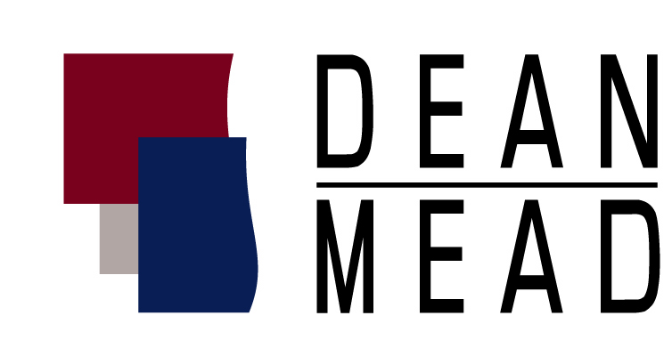
Dean, Mead, Egerton, Bloodworth, Capouano & Bozarth, P.A.
800 N. Magnolia Avenue, Suite 1500
Orlando, FL 32803

June 19, 2013

Contact: Karen M. Keene
407-428-5155
kkeene@deanmead.com

FOR IMMEDIATE RELEASE:

FIFTEEN DEAN MEAD ATTORNEYS NAMED AS FLORIDA SUPER LAWYERS 2013

Orlando, Fla. – The publication Florida Super Lawyers has named 15 attorneys at Dean, Mead, Egerton, Bloodworth, Capouano & Bozarth, P.A. to their annual list of top attorneys in Florida for 2013. No more than five percent of the lawyers in the state are selected.

Darryl M. Bloodworth, Shareholder, was named to the Top 100 Super Lawyers (statewide), an honor he has previously held. The 'Top 100' list is comprised of attorneys selected as 'Super Lawyers' who received the highest points in the nomination, research and blue ribbon review process. In addition, Lauren Y. Detzel, Shareholder, was selected among the ‘Top 50 Women’ lawyers in Florida, and she also been previously recognized for this honor.

Two other Dean Mead attorneys, Melanie S. Griffin and David P. Hathaway, were named to the Florida Rising Stars list for consecutive years. A list of all Dean Mead’s Florida Super Lawyers 2013 honorees is provided as follows:

Attorney Practice Area Office
David J. Akins Estate and Probate Orlando
R. Mason Blake Real Estate Viera
Darryl M. Bloodworth Business Litigation Orlando
John (“Jack”) C. Bovay Estate and Probate Gainesville
more-
Stephen J. Bozarth Real Estate Orlando
Lauren Y. Detzel Estate and Probate and ranked as Orlando
‘Top 50 Women Super Lawyers’ (statewide)
Charles H. Egerton Tax Orlando
Lynn J. Hinson Business Litigation Orlando
Steven C. Lee Tax Orlando
Stephen R. Looney Tax Orlando
Michael D. Minton Tax Fort Pierce
Nichole M. Mooney Employment and Labor Orlando
Joseph J. Van Heyde II Employment Orlando

Rising Stars
Melanie S. Griffin Business Litigation Orlando
David P. Hathaway Business Litigation Orlando

About Super Lawyers:
Super Lawyers, a Thomson Reuters business, is a rating service of outstanding lawyers from more than 70 practice areas that have attained a high degree of peer recognition and professional achievement. The annual selections are made using a rigorous multi-phased process that includes a statewide survey of lawyers, an independent research evaluation of candidates, and peer reviews by practice area. For more information, please visit www.superlawyers.com

About Dean Mead:
Dean Mead is a business law firm that provides full-service legal representation to businesses and individuals throughout Florida. The firm has 45 attorneys practicing in multiple practice areas including: tax, estate and succession planning, corporate, general commercial litigation, employee benefits, bankruptcy and creditors’ rights, real estate and health law. For more information, please visit www.deanmead.com.
# # #

