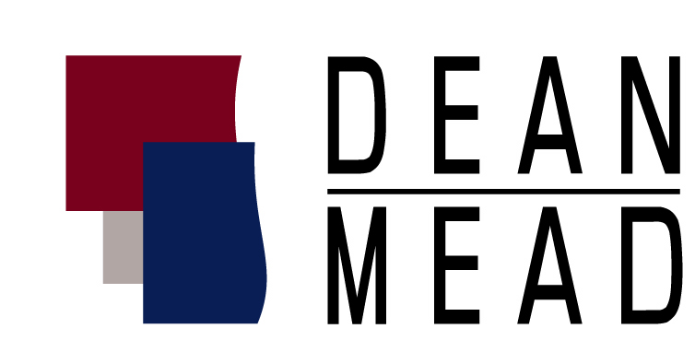
Dean, Mead, Egerton, Bloodworth, Capouano & Bozarth, P.A.
800 N. Magnolia Avenue, Suite 1500
Orlando, FL 32803

June 6, 2013

Contact: Karen M. Keene
407-428-5155
kkeene@deanmead.com

FOR IMMEDIATE RELEASE:

CHAMBERS USA 2013 RECOGNIZES FIVE DEAN MEAD LAWYERS
AS LEADERS IN THEIR FIELD

Orlando, Fla. – Five attorneys from Dean, Mead, Egerton, Bloodworth, Capouano & Bozarth, P.A. have been named as leaders in their field in the 2013 edition of Chambers USA – America’s Leading Lawyers for Business. Shareholder, Lauren Y. Detzel, was selected to the nationwide rankings for her work in Wealth Management in the Eastern Region. In addition, the firm is recognized in Florida for its General Commercial Litigation, Real Estate, Tax and Estate Planning practices.

The five shareholders named as leading attorneys in their respective fields, include:

Attorney Practice Area Office
Darryl M. Bloodworth Commercial Litigation Orlando
Lauren Y. Detzel Estate Planning and also ranked nationally Orlando
in Wealth Management (Eastern Region)
Charles H. Egerton Tax Orlando
Stephen R. Looney Tax Orlando
Michael D. Minton Tax Fort Pierce

Chambers USA honorees are selected on the basis of submissions put forward by legal practices, interviews during the course of research and the Chambers own database resources.
-more-

About Chambers USA:
Chambers USA ranks the firms and lawyers considered leaders in their field through in-depth, unbiased research conducted by its team of highly qualified and experienced researchers. All interviews are entirely confidential and un-attributed, and help the editorial team to assess individual as well as firm wide strengths, areas of expertise and reputation in the market. Greater weighting is given to the opinions of clients, and any biased viewpoints tend to cancel each other out. It is one in a series of Chambers & Partners independent, objective and research-based guides to the legal profession. Chambers researches, compiles and launches completely new editions of the directories each year. For more information, please visit www.chambersandpartners.com/USA.

About Dean Mead:
Dean Mead is a business law firm that provides full-service legal representation to businesses and individuals throughout Florida. The firm has 45 attorneys in multiple practice areas including:
tax, estate and succession planning, corporate business law, general commercial litigation, employee benefits, bankruptcy and creditors’ rights, real estate and health law. For more information, please visit www.deanmead.com.
# # #

